AWS Lambda:
AWS Lambda is a compute service that runs code without the need to manage servers. Your code runs, scaling up and down automatically, with pay-per-use pricing.
When using Lambda, you are responsible only for your code. Lambda runs your code on a high-availability compute infrastructure and manages all the computing resources, including server and operating system maintenance, capacity provisioning, automatic scaling, and logging.
Because Lambda is a serverless, event-driven compute service, it uses a different programming paradigm than traditional web applications.

Executing a basic lambda function:
First search for lambda service and select it
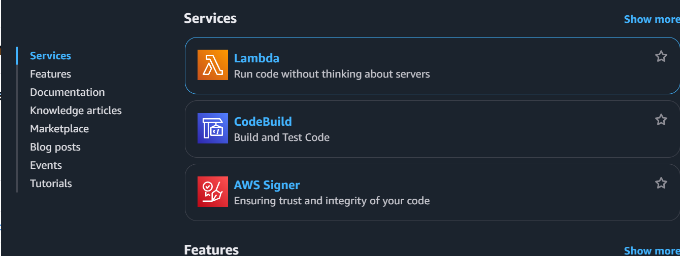
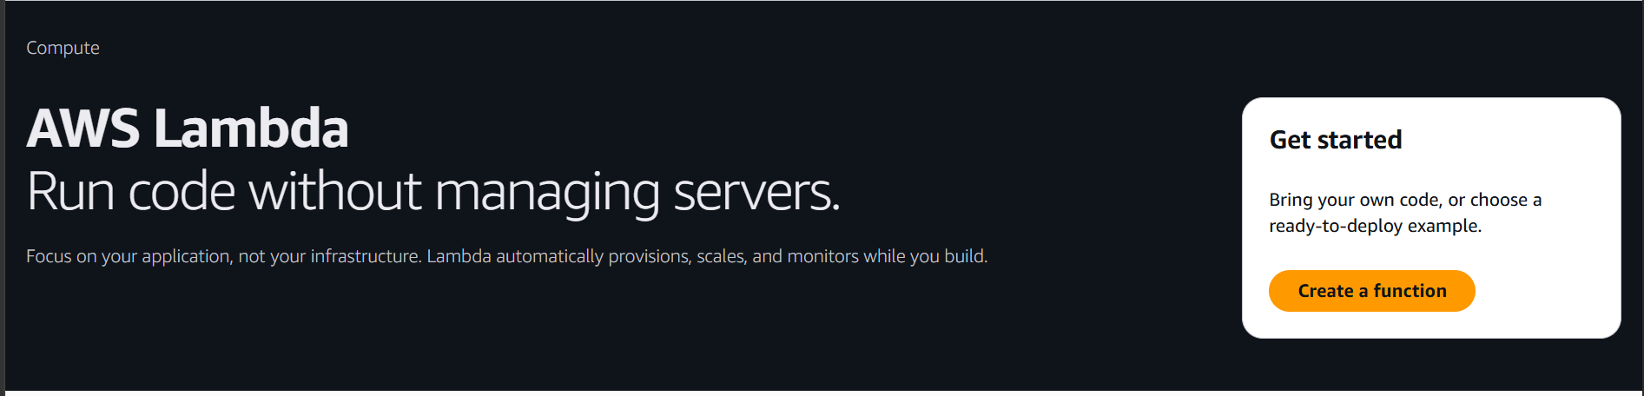

Click on create a function
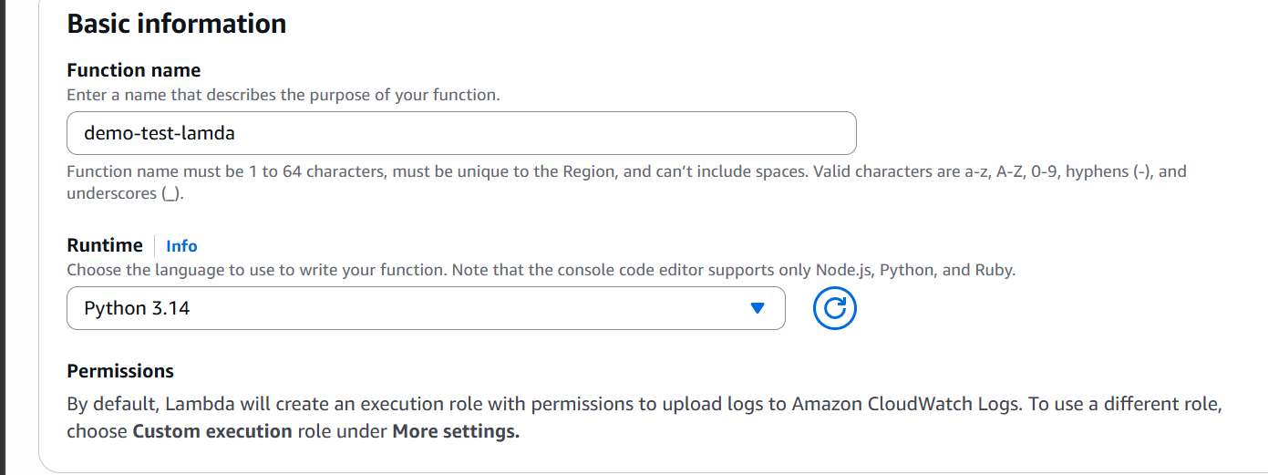

Give a name to the function and select runtime
Now click on create function
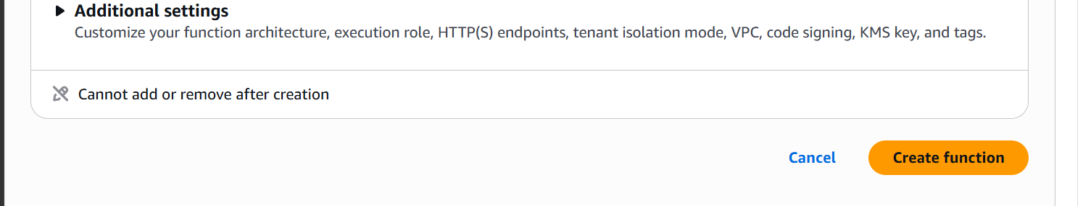

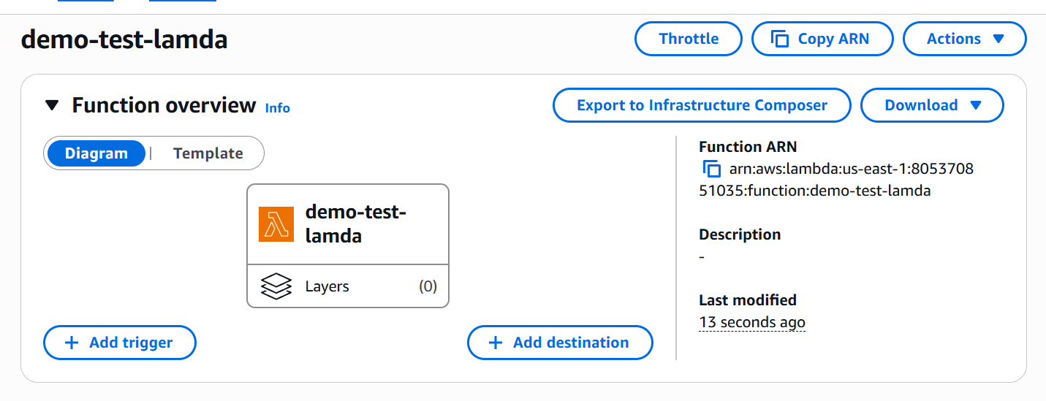

Our function is now created

This is the by default code given by lambda which returns hello from lambda if it is executed successfully.
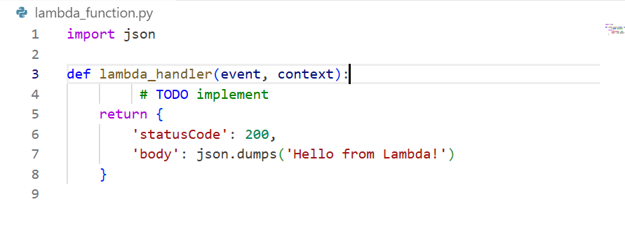

Lets now create a event and test our code
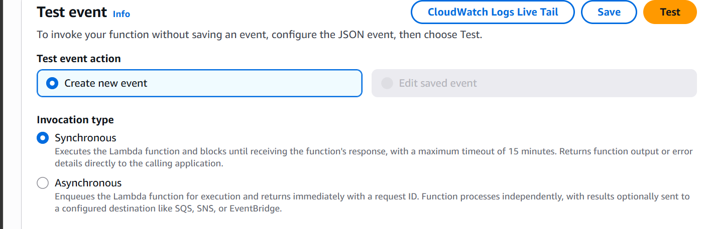
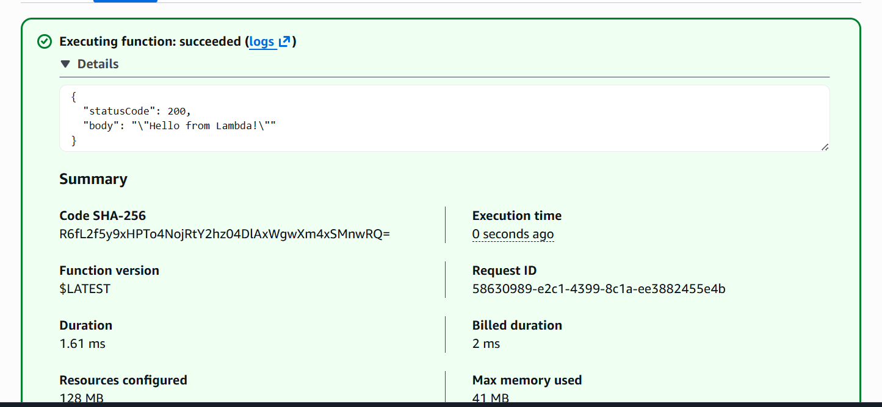

The code is executed successfully.

Now let’s us perform a task.

Auto-Stop EC2 to save cost:

First lets create an ec2 instance
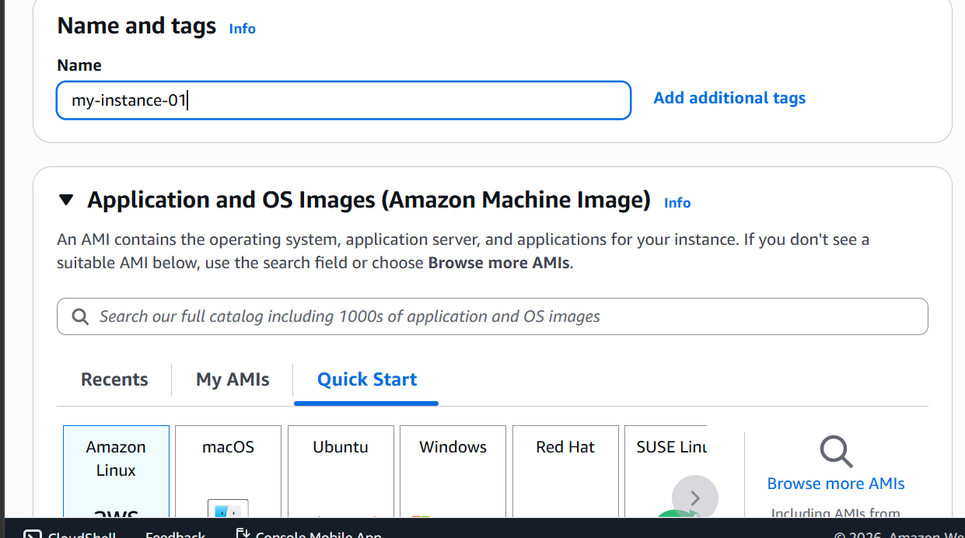

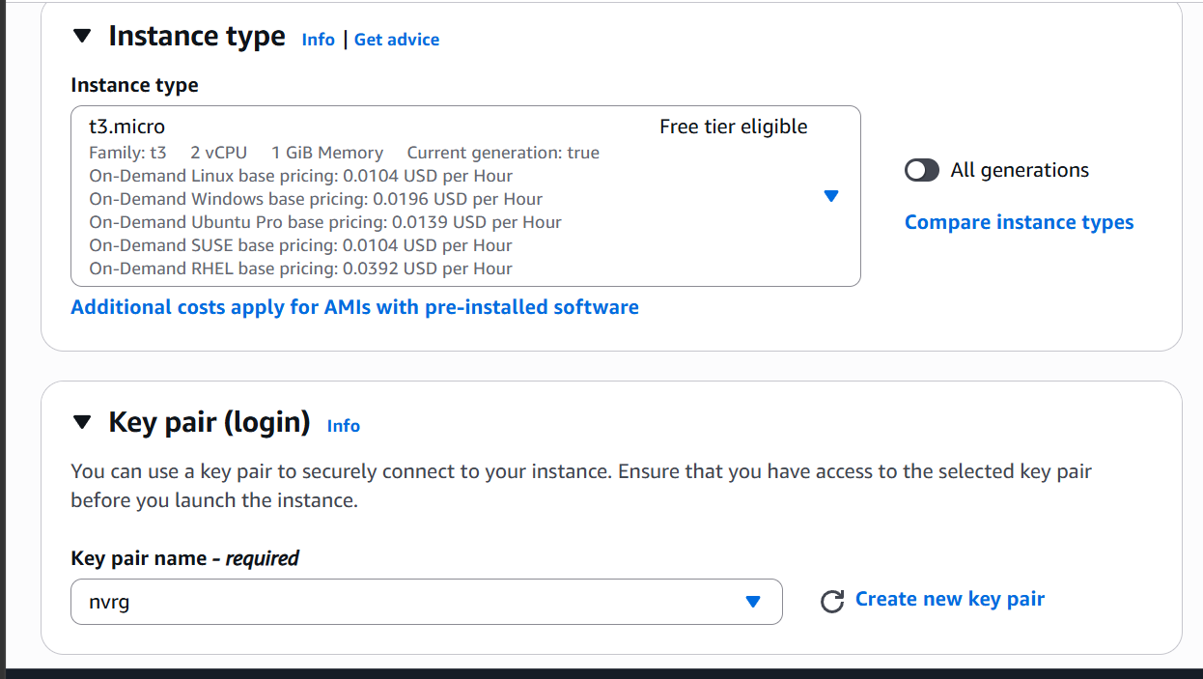
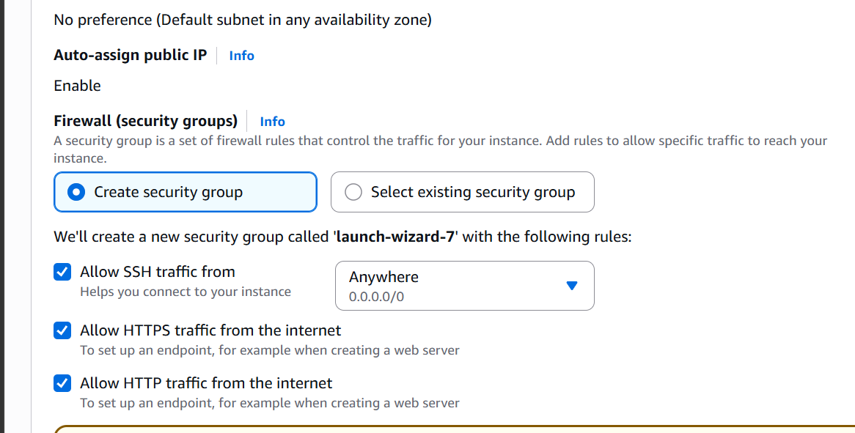
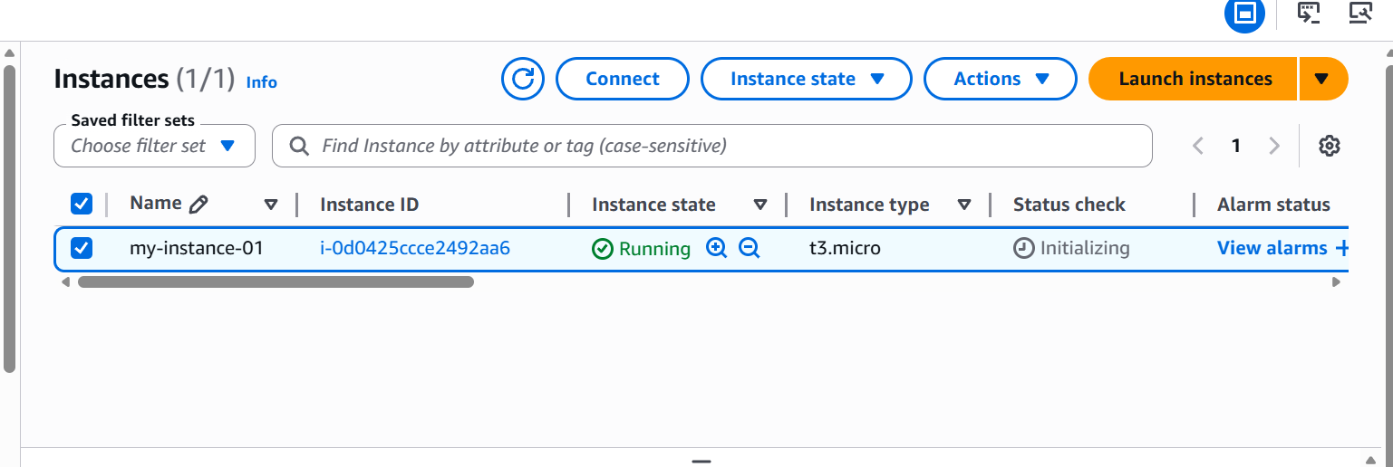

Our instance is now created.

Now lets create a IAM policy for lambda to start stop and describe instances
Go to IAM
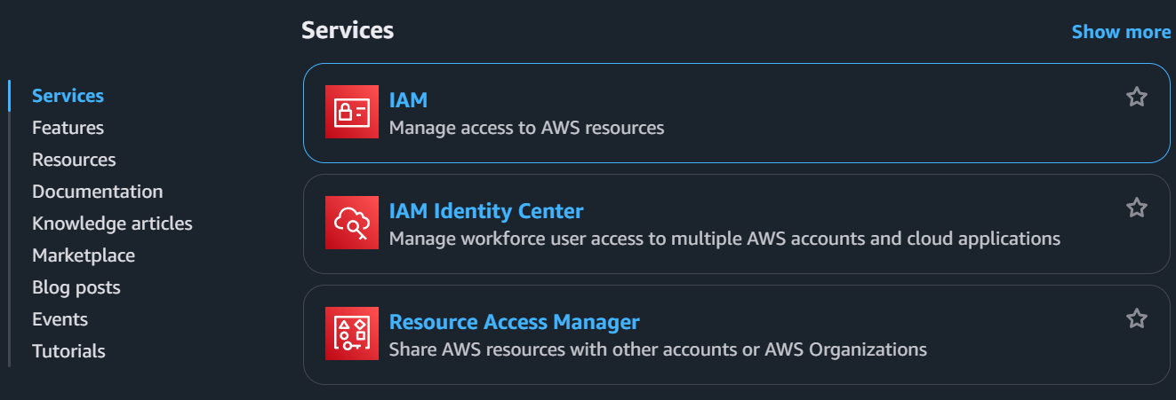
Select policies
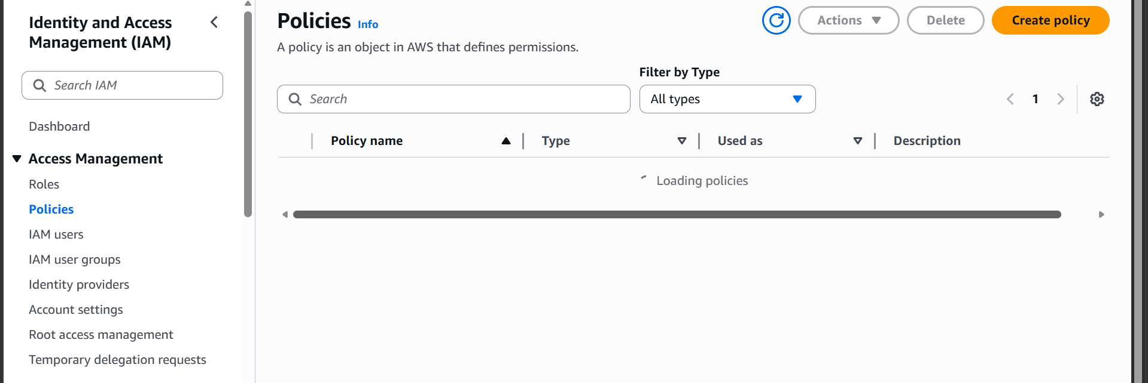

Now click on create policy
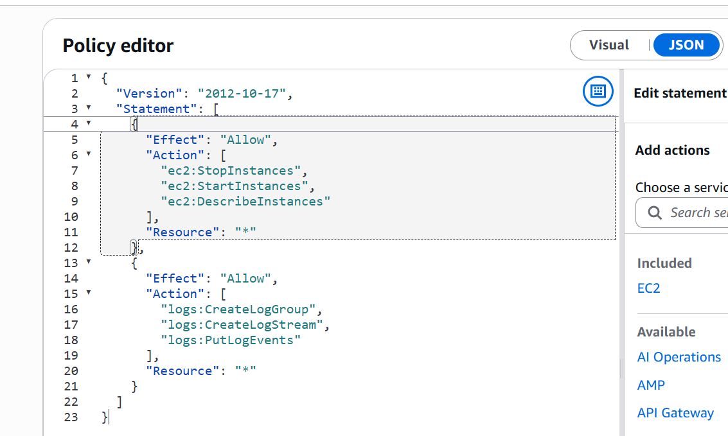

This policy allows lambda to stop, start, describe instances also it allows lambda to write logs or create log groups automatically or create log stream.

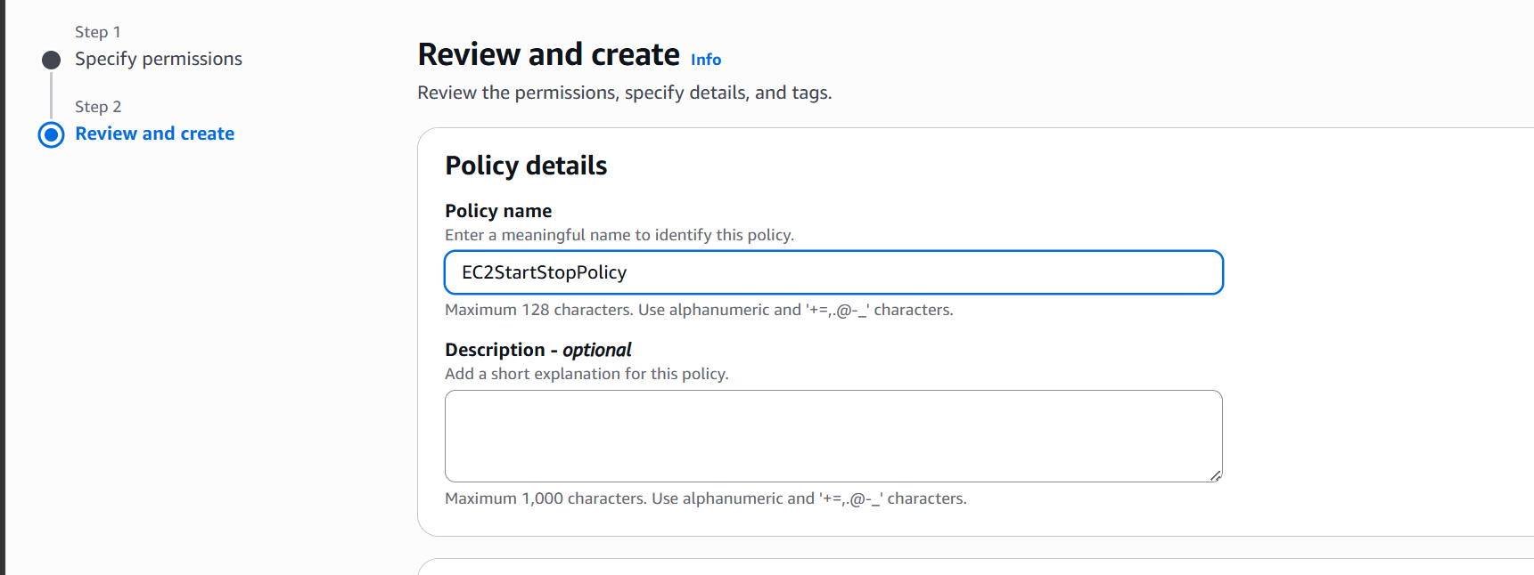

Now click on create policy
Policy is now created
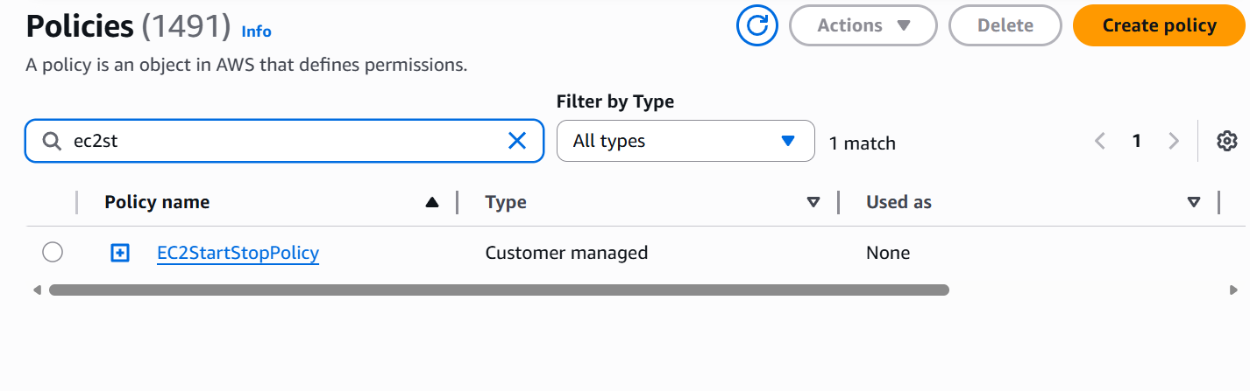

Now lets create a role and attach the policy
Under IAM click on roles
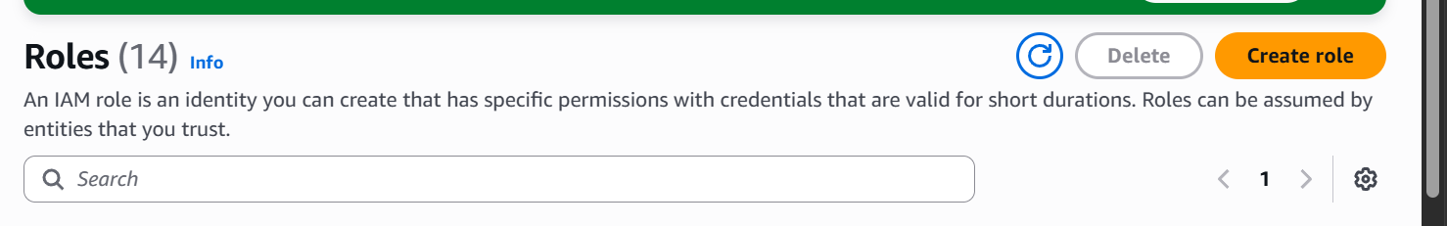
Click on create role
Now select trusted entity AWS service

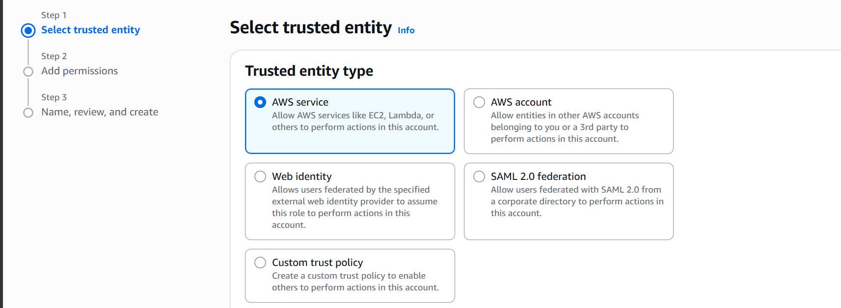

Select use case lambda
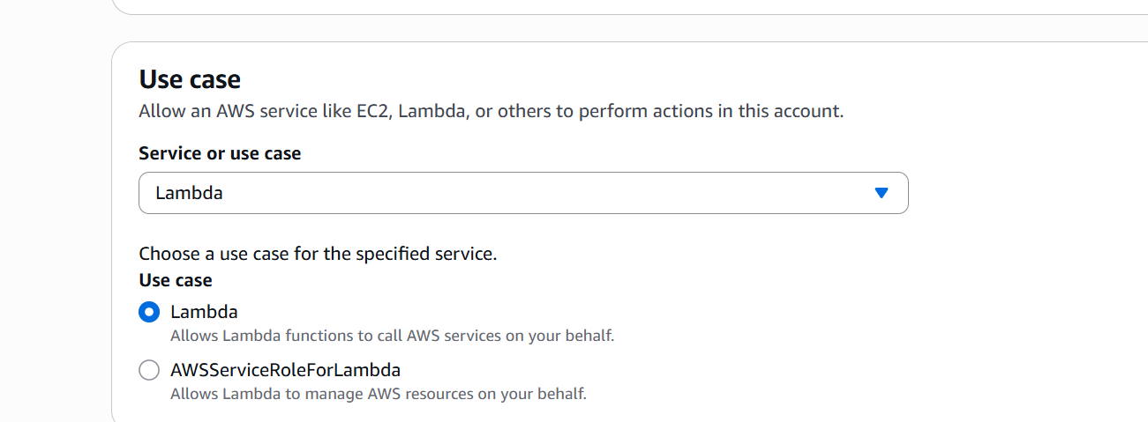
Now attach the policy we created
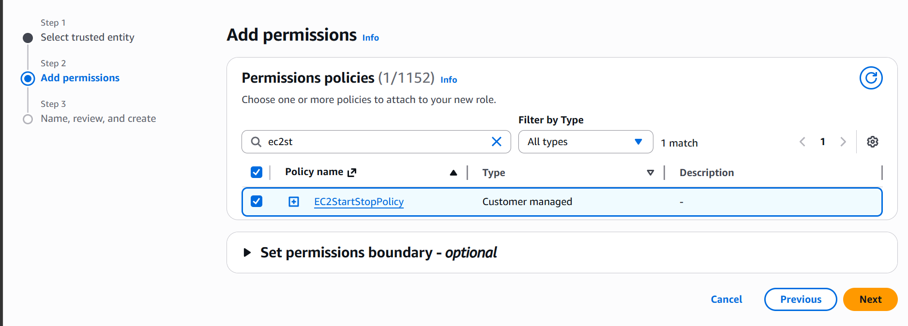

Give the role a name and create
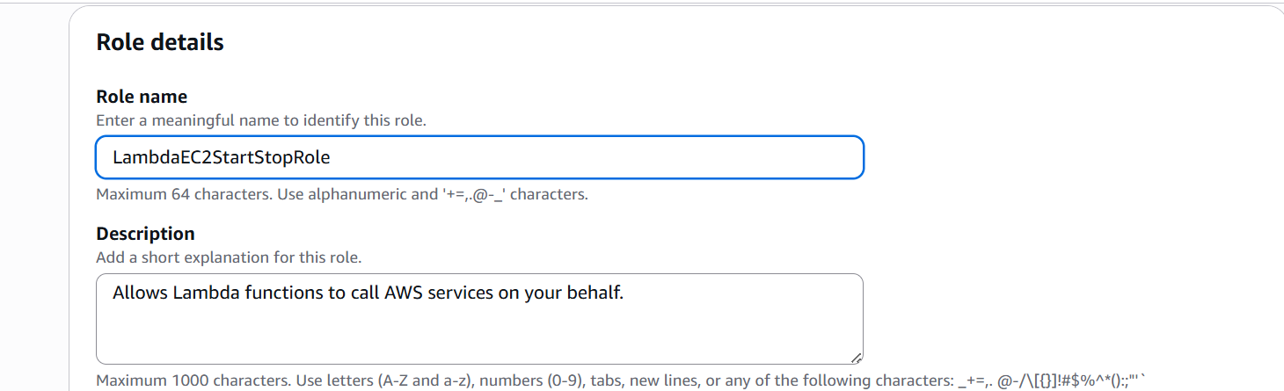

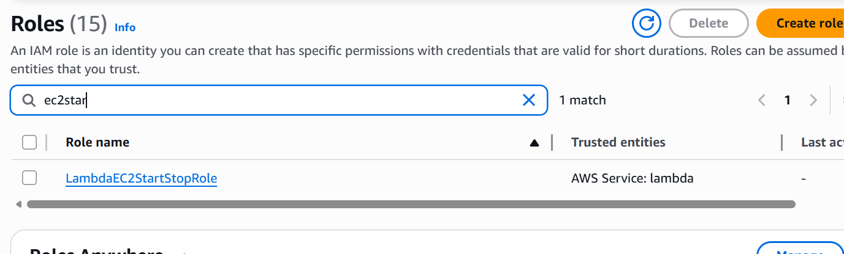
The role is now created

Now create the lambda function
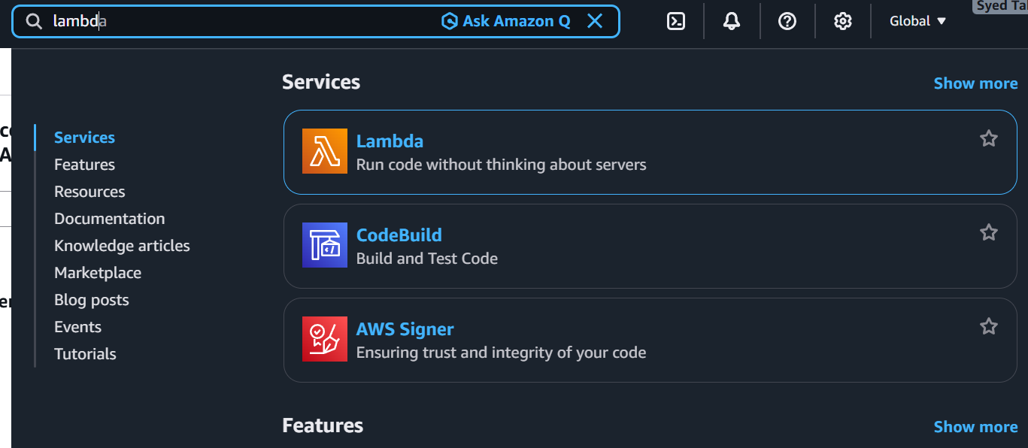

Search for lambda and select

Click on create a function
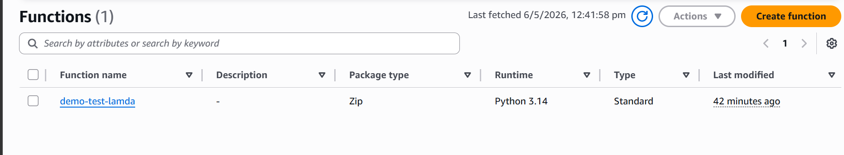

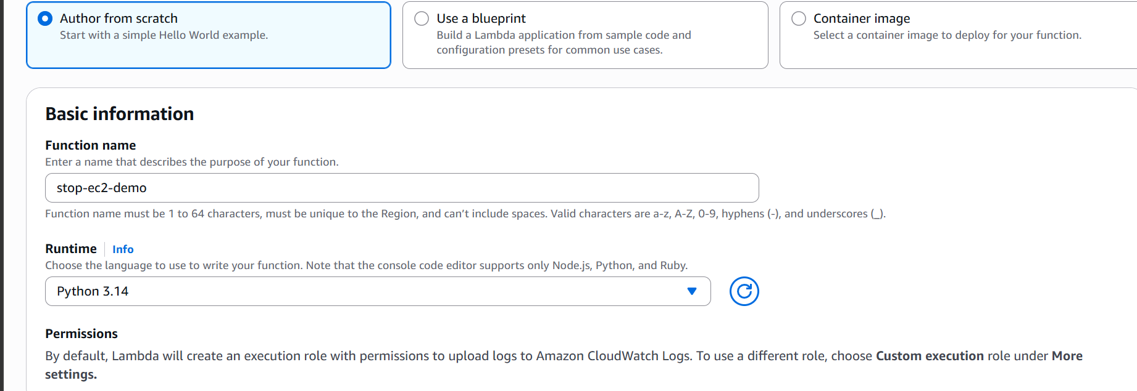

Select author from scratch give a name and select runtime
Under additional settings
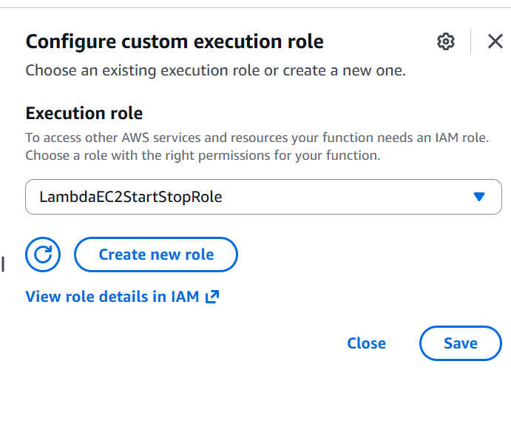

select configure custom execution role and select the role
now create the function
after creating the function let us add the code to stop instance
l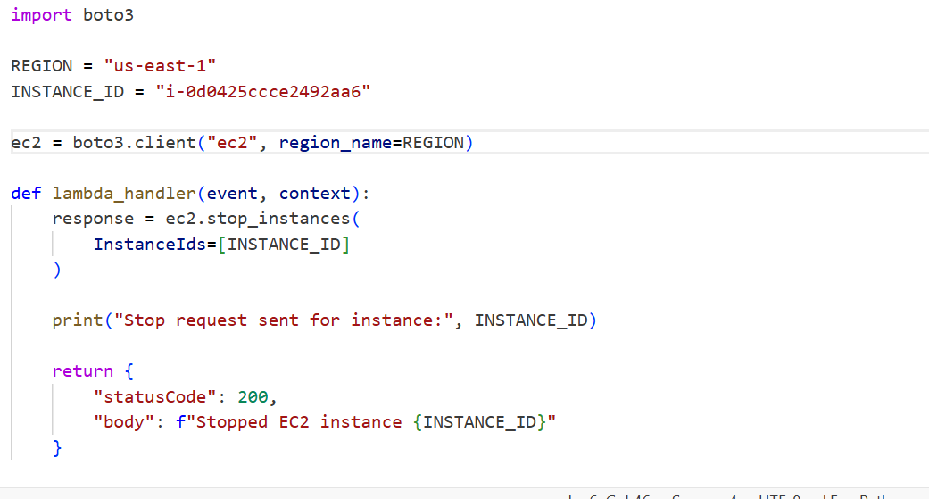
Let us now deploy the code
The code is now deployed
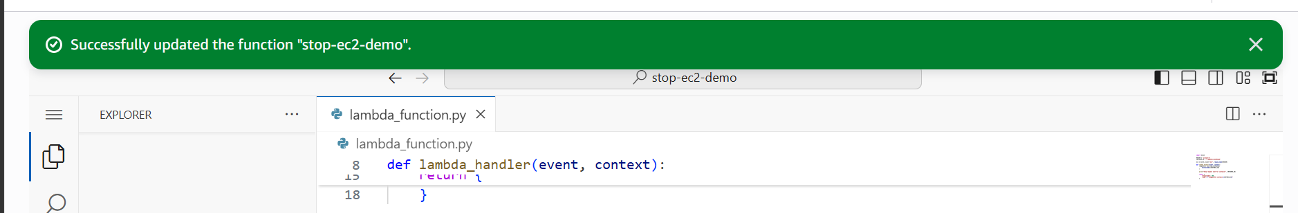

Let us now test it
Create a new event
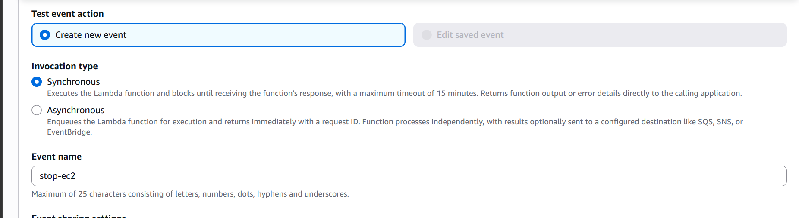
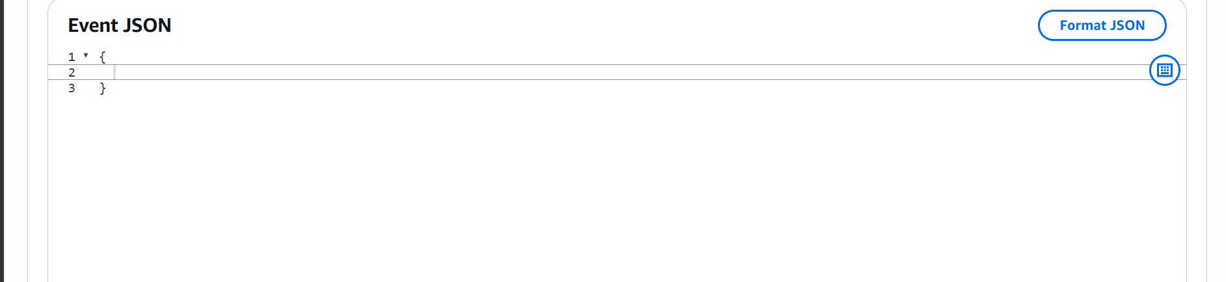

The test is now executed successfully
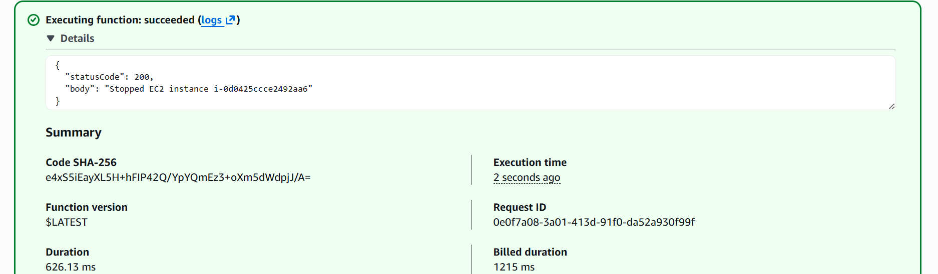
Let us see if the instance is stopped
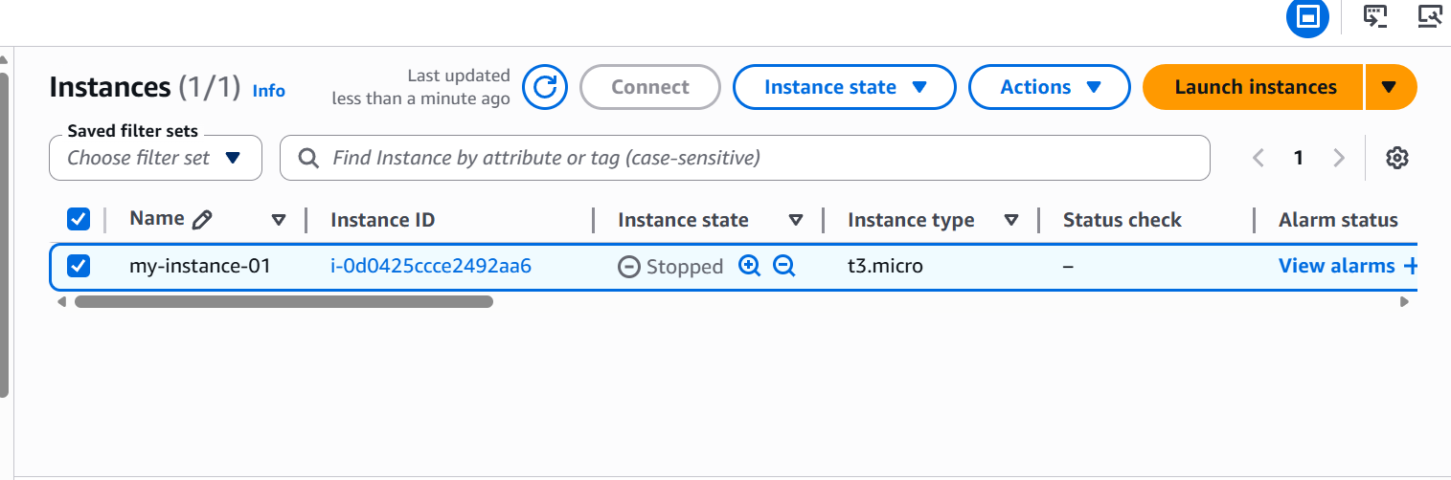

We can see that the instance is stopped when the function is executed.
The log group is created as well.
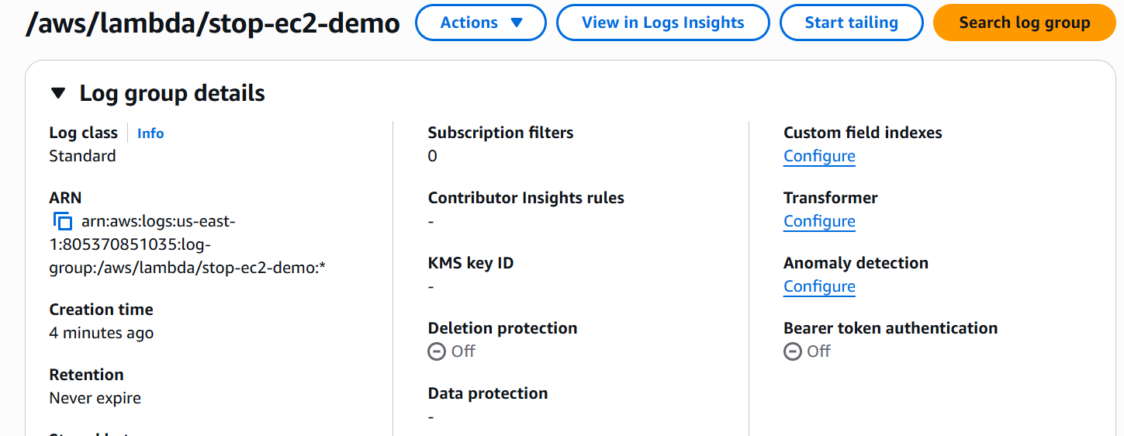
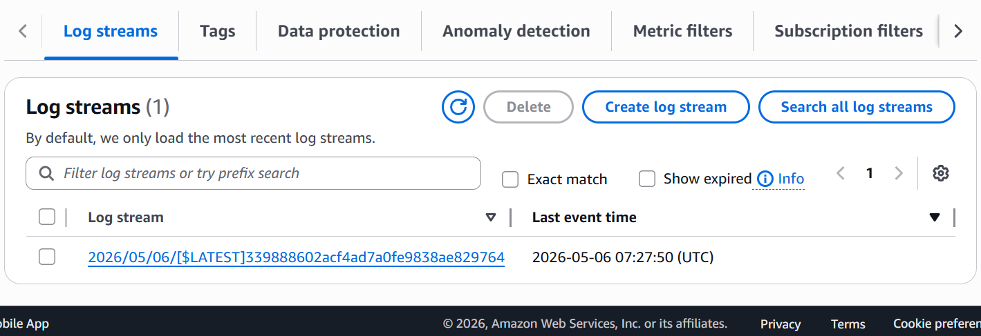
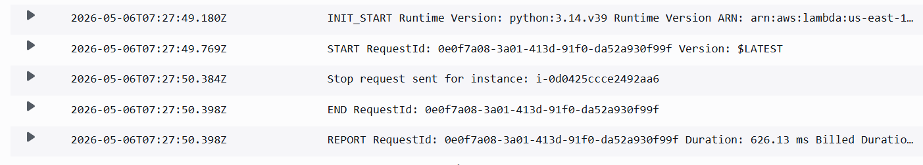

The logs are generated as well.

